**Child Bicyclist**

Welcome to the bike safety quiz! Let's get started.

There are three quiz levels - Bronze (12 questions), Silver (7 questions), and Gold (6 questions).  For each question, click the best choice and then click Next. When you get a question wrong, we'll tell you why. You will have three chances to get the right answer. If you need to, you can exit the quiz and finish later.

If you finish at least one level, you can create a Certificate of Completion, to print or e-mail.

Good luck!

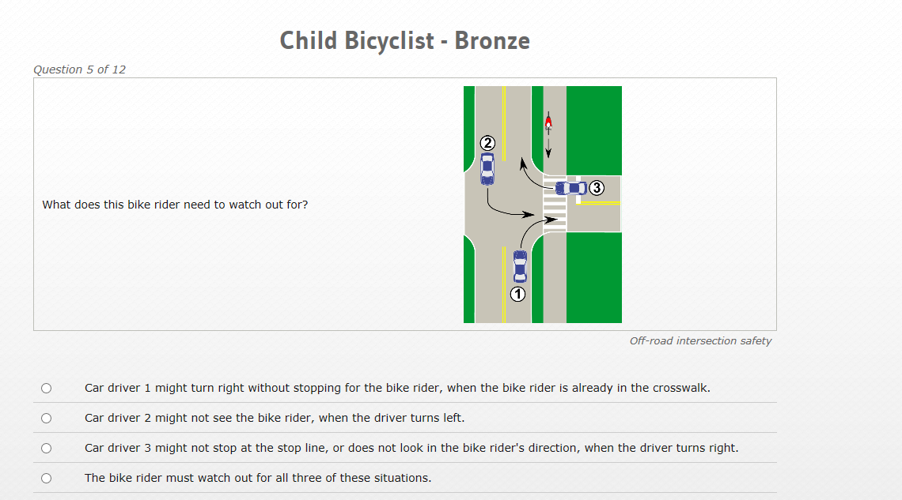

**Response:**

|  |  |
| --- | --- |
|  | Car driver 1 might turn right without stopping for the bike rider, when the bike rider is already in the crosswalk. |
|  | Car driver 2 might not see the bike rider, when the driver turns left. |
|  | Car driver 3 might not stop at the stop line, or does not look in the bike rider's direction, when the driver turns right. |
|  | The bike rider must watch out for all three of these situations. |
| **Feedback:**  Correct!  When you bike in this direction on a sidewalk, it's harder for car drivers to see you when they turn at intersections.  You are not where drivers are looking when the drivers are deciding when to make their turn.  Also, drivers make mistakes by not looking both ways.  So, you must watch carefully and be ready to stop. |

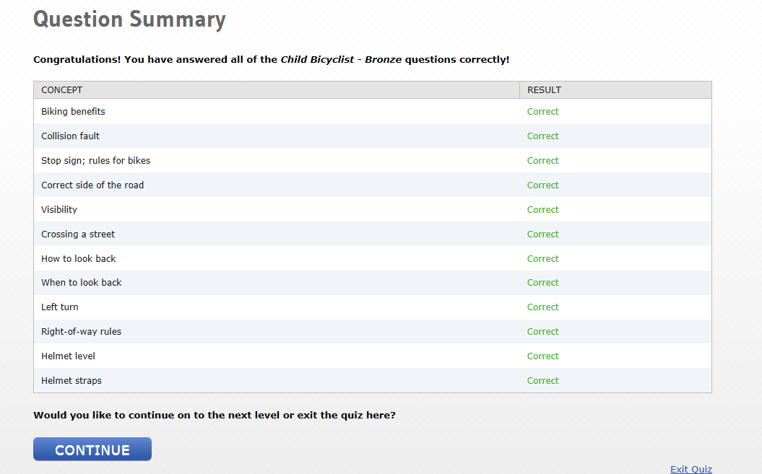

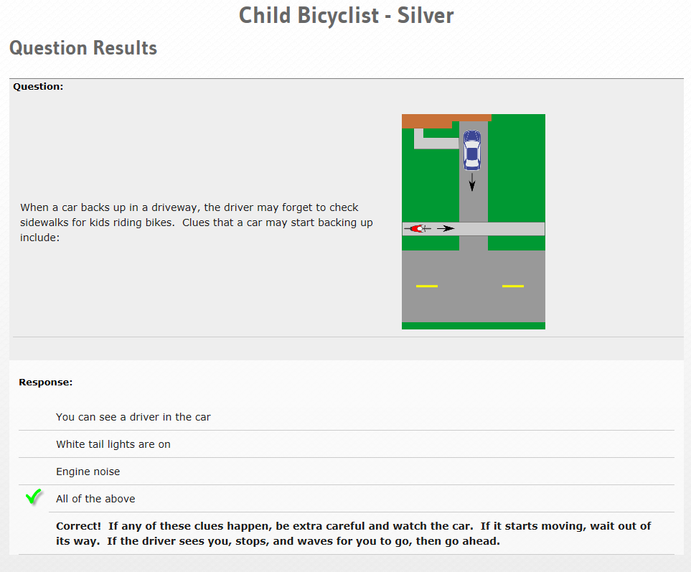

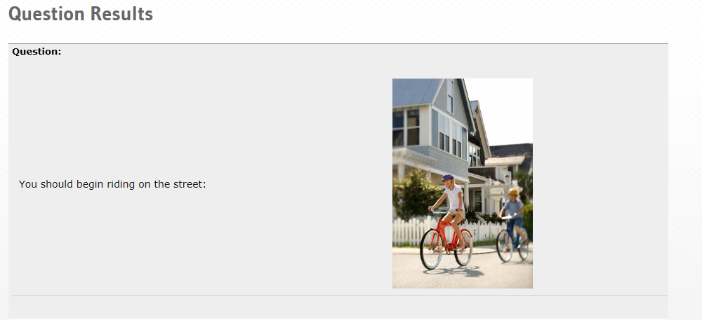

**Response:**

|  |  |
| --- | --- |
|  | Bicycles are not allowed on the street |
|  | When your parent says it is okay |
| **Feedback:**  Correct!  For many kids, age 10 is a good age to start riding on roads that are not busy.  However, some kids may be ready earlier, and some later.  Your parent knows best whether you're ready. |
|  | At age 10 |
|  | When you can bike fast enough, like 20 miles per hour |

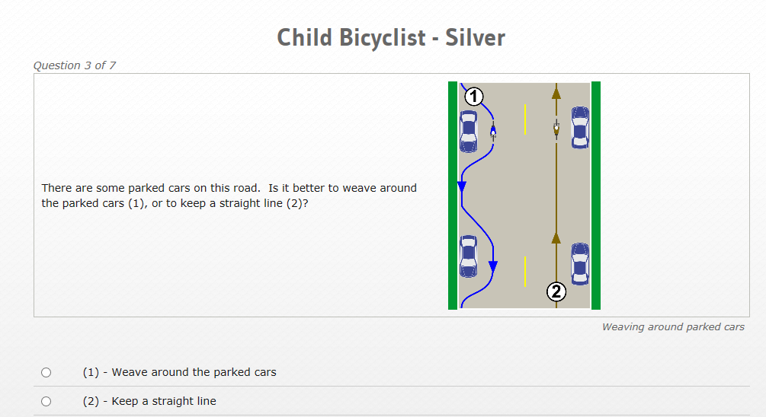

**Response:**

|  |  |
| --- | --- |
|  | (1) - Weave around the parked cars |
|  | (2) - Keep a straight line |
| **Feedback:**   |  |  | | --- | --- | | Correct!  Biking in a straight line here is safer and more predictable - meaning car drivers know what the bike rider will do next.  In (1), it is hard for car drivers to know when, and how far, a bike rider will weave.  If you do have to move left to go around something, be sure to look in back of you for cars coming. | http://www.bikesafetyquiz.com/sites/default/files/images/ChildSilver3_Post.png | |

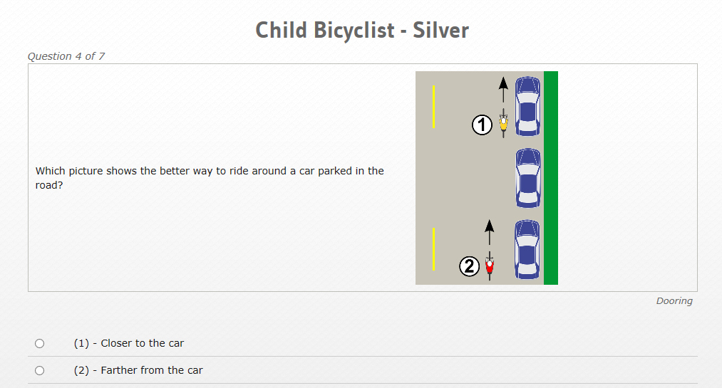

**Response:**

|  |  |
| --- | --- |
|  | (1) - Closer to the car |
|  | (2) - Farther from the car |
| **Feedback:**   |  |  | | --- | --- | | Correct!  The driver's door may open into your path.  You might hit it if you are too close.  Ride farther out, so this does not happen.  Also, as you get closer to the car, try to see if there is a driver inside.  If there is, then be even more alert for the car door opening. | http://www.bikesafetyquiz.com/sites/default/files/images/ChildSilver4_Post.png | |

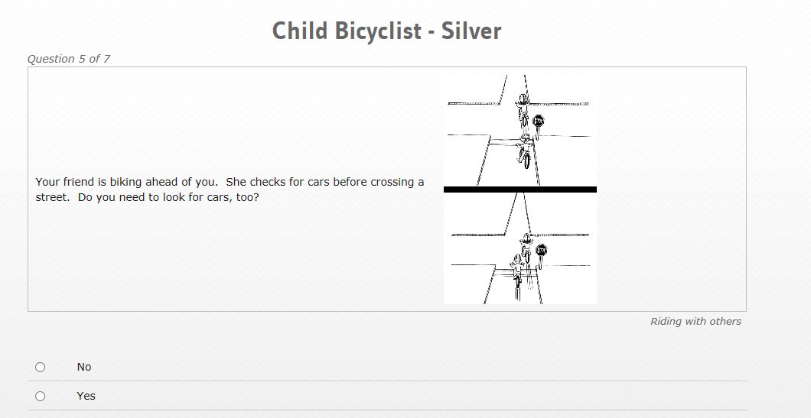

**Response:**

|  |  |
| --- | --- |
|  | No |
|  | Yes |
| **Feedback:**   |  |  | | --- | --- | | Correct!  When YOU get to the street, it may not be safe to cross anymore.  You have to make your own decision on when it is safe to go.  Slow down or stop, and look LEFT, RIGHT, LEFT for cars. | http://www.bikesafetyquiz.com/sites/default/files/images/ChildSilver5_Post.png | |

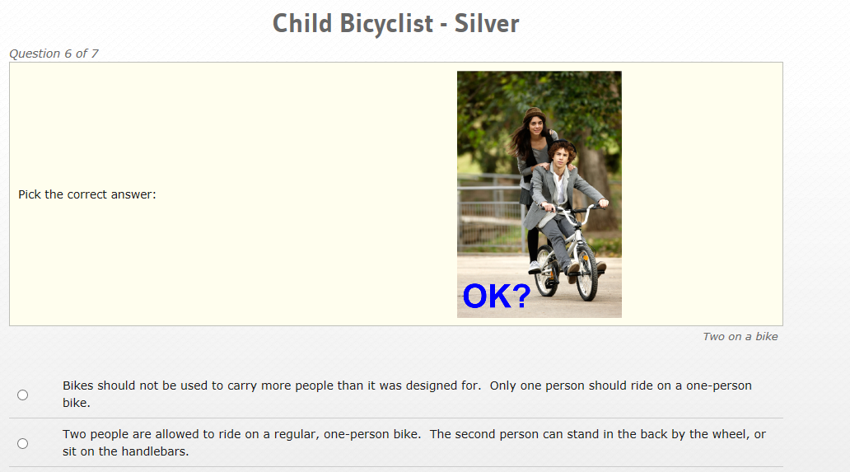

**Response:**

|  |  |
| --- | --- |
|  | Bikes should not be used to carry more people than it was designed for.  Only one person should ride on a one-person bike. |
| **Feedback:**   |  |  | | --- | --- | | Correct.  This is what the law says.  Standing on the back by the wheel, or sitting on the handlebars, is not safe. | http://www.bikesafetyquiz.com/sites/default/files/images/ChildSilver6_Post.png | |

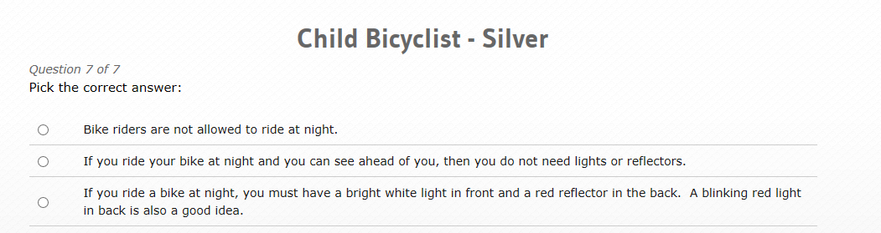

**Question:**

Pick the correct answer:

**Response:**

|  |  |
| --- | --- |
|  | Bike riders are not allowed to ride at night. |
|  | If you ride your bike at night and you can see ahead of you, then you do not need lights or reflectors. |
|  | If you ride a bike at night, you must have a bright white light in front and a red reflector in the back.  A blinking red light in back is also a good idea. |
| **Feedback:**   |  |  | | --- | --- | | Correct!  It's very  important that drivers can see bike riders at night.  Lights, and bright clothes, help that. | http://www.bikesafetyquiz.com/sites/default/files/images/ChildSilver7_Post.png | |

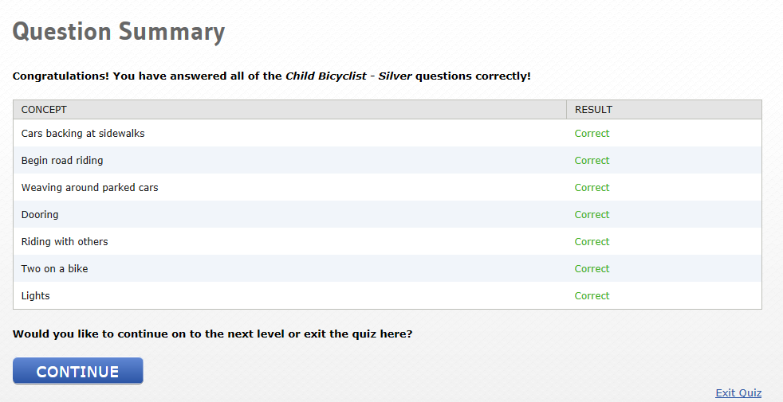

**Child Bicyclist - Gold**

*Question 1 of 6*

|  |  |
| --- | --- |
| Look at the bike's back tire in these pictures.  Which show the correct amount of air in the tire? | http://www.bikesafetyquiz.com/sites/default/files/images/ChildGold1_Pre.png |

Top of Form

*Tire pressure*

Choose one

|  |  |
| --- | --- |
|  | (1) - The pictures on top.  There is more air in the tires.  You can only pinch the tires a very little bit. |
|  | (2) - The pictures on bottom.  There is less air in the tires.  You can pinch the tires more. |

Bottom of Form

**Response:**

|  |  |
| --- | --- |
|  | (1) - The pictures on top.  There is more air in the tires.  You can only pinch the tires a very little bit. |
| **Feedback:**   |  |  | | --- | --- | | Correct!  When your tire has enough air, it is easier to bike, it is safer, and you have less chance of getting a flat tire.  Use an air pump to fill your tires to the number printed on the side of your tire.  Then, pinch the tire to learn how it feels when it is full.  Do a pinch test each time before you ride. | http://www.bikesafetyquiz.com/sites/default/files/images/ChildGold1_Post.png | |
|  | (2) - The pictures on bottom.  There is less air in the tires.  You can pinch the tires more. |

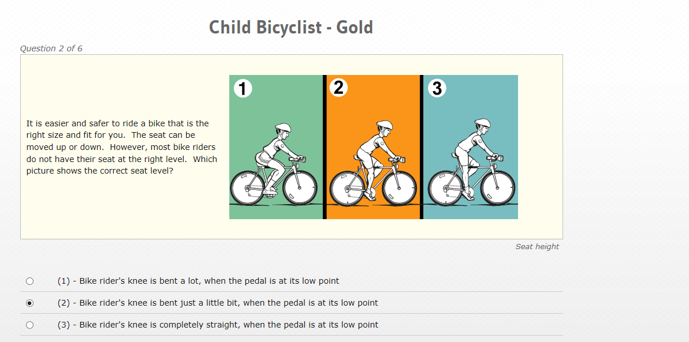

**Response:**

|  |  |
| --- | --- |
|  | (1) - Bike rider's knee is bent a lot, when the pedal is at its low point |
|  | (2) - Bike rider's knee is bent just a little bit, when the pedal is at its low point |
| **Feedback:**   |  |  | | --- | --- | | Correct!  The seat is at the right place for this bike rider. | http://www.bikesafetyquiz.com/sites/default/files/images/ChildGold2_Post_0.png | |
|  | (3) - Bike rider's knee is completely straight, when the pedal is at its low point |

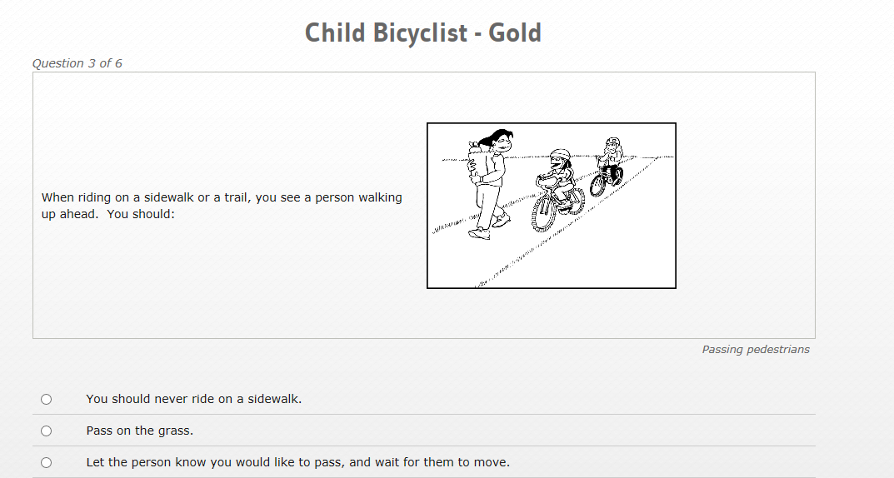

**Response:**

|  |  |
| --- | --- |
|  | You should never ride on a sidewalk. |
|  | Pass on the grass. |
|  | Let the person know you would like to pass, and wait for them to move. |
| **Feedback:**  Correct!  When you ride near people walking, don't surprise them!  Slow down, and say "Excuse me" or use a bell or horn.  When they move over, then you can go. |

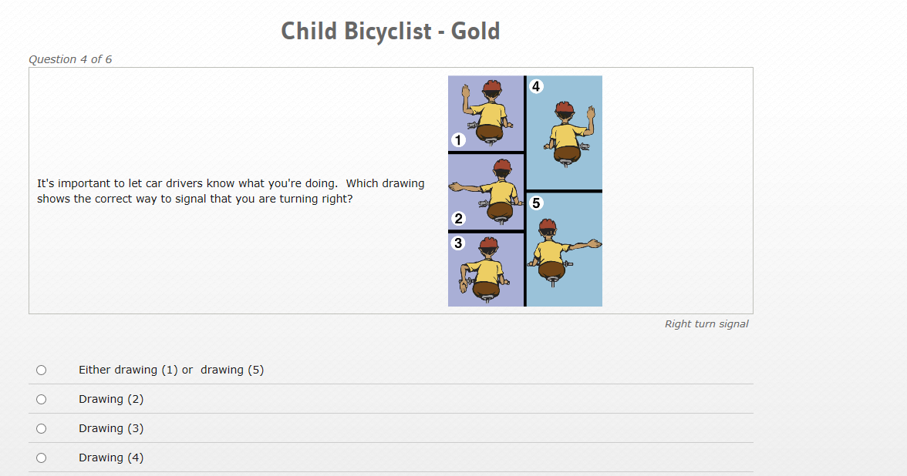

**Response:**

|  |  |
| --- | --- |
|  | Either drawing (1) or  drawing (5) |
| **Feedback:**   |  |  | | --- | --- | | Correct!  You can do either (1) or (5), but more car drivers might know that (5) means a right turn. | http://www.bikesafetyquiz.com/sites/default/files/images/ChildGold4_Post.png | |
|  | Drawing (2) |
|  | Drawing (3) |
|  | Drawing (4) |

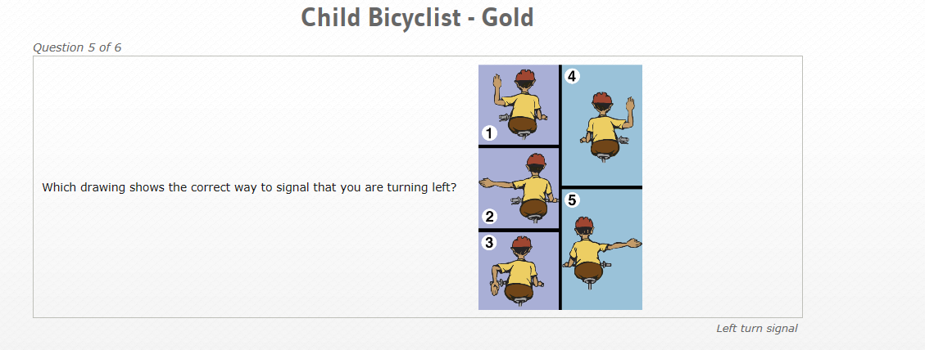

**Response:**

|  |  |
| --- | --- |
|  | Either drawing (1) or drawing (5) |
|  | Drawing (2) |
| **Feedback:**   |  |  | | --- | --- | | Correct! | http://www.bikesafetyquiz.com/sites/default/files/images/ChildGold5_Post.png | |
|  | Drawing (3) |
|  | Drawing (4) |

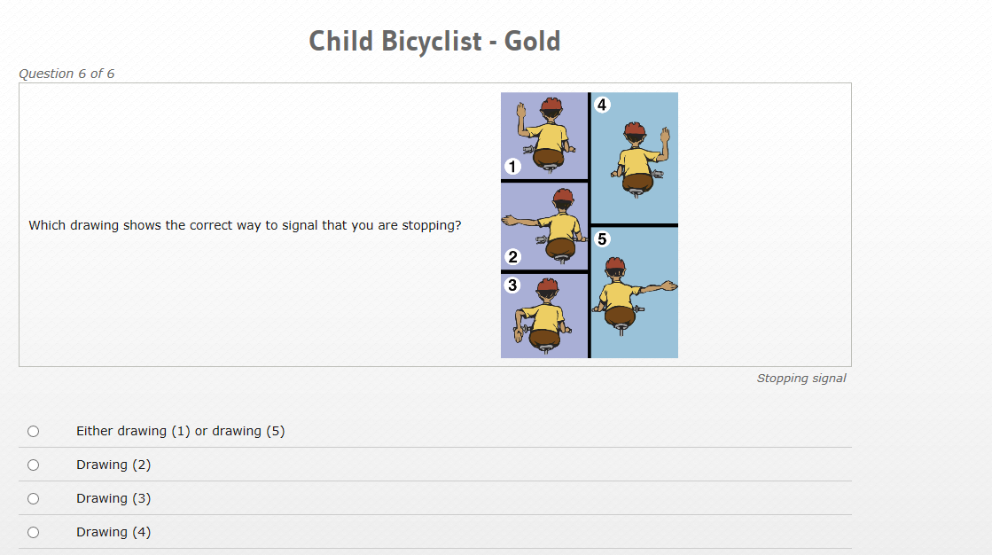

**Response:**

|  |  |
| --- | --- |
|  | Either drawing (1) or drawing (5) |
|  | Drawing (2) |
|  | Drawing (3) |
| **Feedback:**   |  |  | | --- | --- | | Correct!  It's important to let drivers know what you plan to do.  Hand signals let drivers know when you are turning or stopping. | http://www.bikesafetyquiz.com/sites/default/files/images/ChildGold6_Post.png | |
|  | Drawing (4) |

